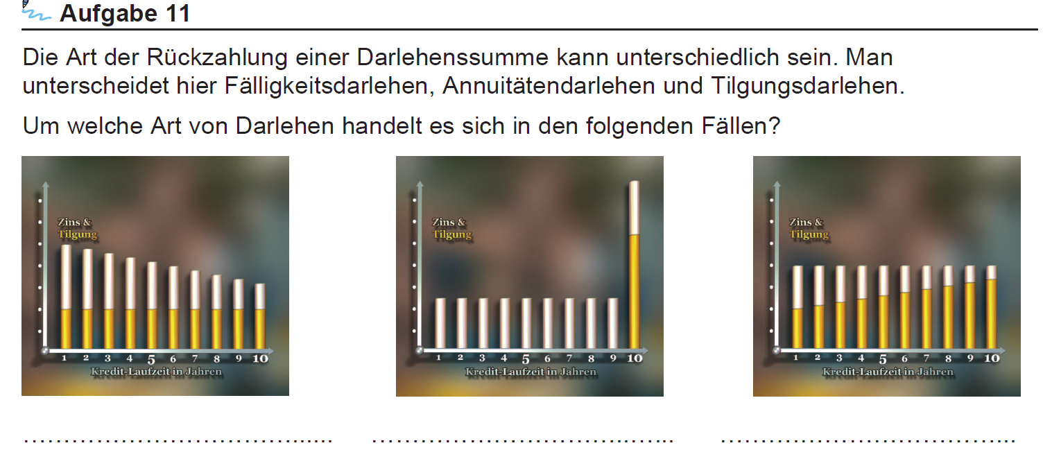

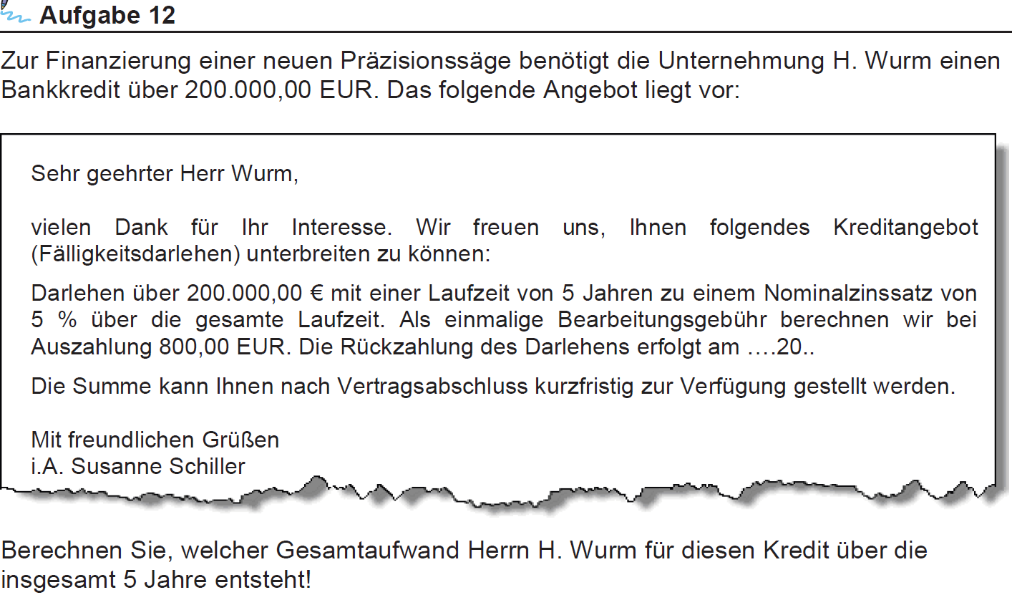

|  |  |  |  |  |  |
| --- | --- | --- | --- | --- | --- |
| **Jahre** | **Darlehen** | **Zinsen** | **Tilgung** | **Restdarlehen** | **Gesamtaufwand** |
| **1** |  |  |  |  |  |
| **2** |  |  |  |  |  |
| **3** |  |  |  |  |  |
| **4** |  |  |  |  |  |
| **5** |  |  |  |  |  |
| **Summe** |  |  |  |  |  |

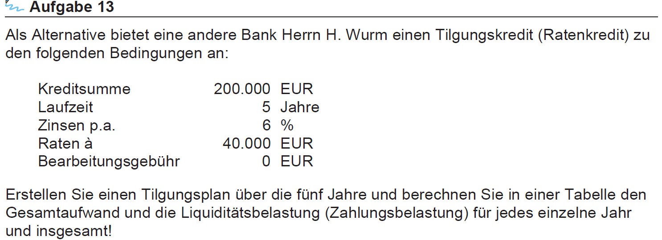

|  |  |  |  |  |  |
| --- | --- | --- | --- | --- | --- |
| **Jahre** | **Darlehen** | **Zinsen** | **Tilgung** | **Restdarlehen** | **Gesamtaufwand** |
| **1** |  |  |  |  |  |
| **2** |  |  |  |  |  |
| **3** |  |  |  |  |  |
| **4** |  |  |  |  |  |
| **5** |  |  |  |  |  |
| **Summe** |  |  |  |  |  |

